Computer Language Coding Concepts

Remove
A related list item’s system interfaces has a Remove command.

The system member Remove is part of the system interface of a related list item and is displayed in a diagram as follows:

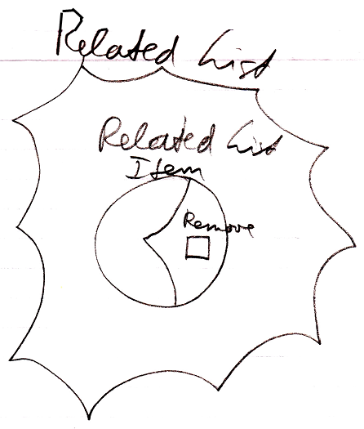

The Remove command removes an item from the list. The object is only removed from the list. The Remove command does not remove the object from everywhere else the object is referred to.

The procedure around the Remove command can be extended with extra functionality, as explained in the section Extending the System Interface.

See also: System Objects, Related List Item, Extending the System Interface

Author & Copyright: Jan-Joost van Zon Date: July 17, 2008 – July 24, 2009 Location: Oosterhout, The Netherlands Status: Finished

